DJ/MC MUSIC SERVICES WORKSHEET All Family Events DJ & More
allfamilyevents.com info@allfamilyevents.com 925-812-2335
Please fill out the following questionnaire (Edit this document, rather than printing and writing in your choices) and return by E-mail.
Client Information
Contact Names:
Phone Numbers:
E-Mail Addresses:
Event Location: |  |  | Room:
Type of Function: | Anniversary |  |  | # Of Guests:
Day: | Date: | Start Time: |  | End Time:
Vendors
Photographer Start time: Ending: | Video Start time: Ending:
Photo Booth: Start time: Ending:
Any special photos during the reception we should know about YES NO (i.e., group picture of all your guests, sunset picture)

Any special entertainment during the reception we should know about YES NO
(i.e., Hula Dancers, Belly Dancers, Band, Singers, Lion Dancers)

Cocktail Hour & AnniversaryReception

For Cocktail Hour and Dinner Music please pick a genre/style rather than providing a list.
Soft Contemporary Jazz Lite Classic Rock Country Motown/RnB DJ Choice Other:
What time do you wish to invite the guests to find their seats?

Bride and Groom Announced as:
Mr. & Mrs. Smith / Mr. & Mrs. John & Jane Smith / John & Jane Smith / John & Jane / The Smiths, John & Jane
Will there be a Welcome Speech (Traditionally given by Groom) YES NO
Given by:
Will there be a Blessing Prior to Dinner YES NO
Given by:
Dinner Service
If you have a buffet dinner your DJ will release the tables starting with the head table and parent’s tables and working their way around to the rest of the room. Music during dinner can be a continuation of your Cocktail hour music, or a different style:
What time is Dinner is scheduled to begin ________ and the meal is Plated Buffet.

Formal Toasts
Formal Toasts can take place prior to, or after dinner. Traditionally the Best Man, Maid of Honor, and Parents” give toasts. You are welcome to schedule whomever you want. We do recommend limiting formal toasts to 3 to 4 people.
Would you like toasts to be Prior to Dinner After Dinner
Preferred Order:
1.
2.
3.
4.
Additional Toasters:
Do you want the DJ To invite your guests to make a toast (Open Mic) YES NO
Will you also be going to each table for YES NO Table Toasts Table Pictures Table Greetings
This is also not recommended for large groups due to the amount of time it takes to complete.
Things DJ/MC needs to remind your guests about (Please highlight reminders)
Guestbook, Cameras on the Tables, Wine Bottle to Sign, Photobook, Framed Picture of the Bride and Groom to Sign, Tree Picture (Guests Place a fingerprint on a branch and sign it), Wedding Favors, Coffee Station, Candy Bar, Gelato Cart, Chocolate Fountain, Shuttles, Money Tree, Bride & Groom’s Special Drink, Social Media #'s ____________________________________ __________________________________________________
Anniversary Reception
Will there be a Video / Photo Slideshow YES NO, Person setting up the video?
Video Technician is available for an extra fee of $95.00, please consult with your DJ to make the arrangements!!
When will the video be played During Cocktails During Dinner After Dinner
Do you want any specialty games ( Shoe Game, Scavenger Hunt, songs, etc.) YES NO
If YES, who will MC the games, songs, etc. DJ Other:
Please describe what games, song, etc. you want:
Will there be any outside entertainers or musicians during the reception YES NO
If YES, Will they need additional Microphones or Equipment YES NO

Anniversary Reception Special Songs
Anniversary Dance: (Artist - Title)
Do you wish to do your First Dance? Following the Introductions or After Formal Toasts
Do you wish to fade the First Dance song early YES NO If so at what point?
Is your First Dance a Choreographed Routine YES NO

Thank You Toast by Bride and Groom: YES NO  If you are doing Table Touches you do not need to do a Thank You |  | Both Bride Groom
Do you wish to do your Thank You Toast following the Formal Toasts or Before the Cake Cutting
Cake Cutting: YES NO | (Artist - Title)
Final Song of the Night: | (Artist - Title)
Would you like your guests to escort you out at the end of the night YES NO
Will you have Sparkler or bubbles YES NO
Is there a limousine or car picking you up YES NO What Time?
Are you planning on having an After Party YES NO Announce the location YES NO
Location of the After Party:

Dance Music Information
Below is a list of music categories. Your DJ will consult with you to determine your wishes using this information. Please fill it out as thoroughly as possible. The standard is to play a variety from all these genres during your event. For full variety, please check that selection (Full Variety). For a greater emphasis in a particular category, please indicate this by checking the applicable box(es). If you do not want one of the categories, please cross it off.

Full Variety Big Band Oldies 50's-60's Motown Disco Funk 80's Dance 80's Hip Hop 90's Dance 90's Hip Hop
2000's Dance 2000's Hip Hop 2010's Dance 2010's Hip Hop Current Top 40 Hip Hop Bay Area Country Classic Rock
Salsa Merengue Cumbia Bachata Banda Cha Cha's

Line Dancing Songs (If not check, will not be played)
Cha Cha Slide Chicken Dance Cotton Eyed Joe Cupid Shuffle Electric Slide Gangnam Style Macarena Wobble YMCA

Musical DANCE REQUESTS: (Artist - Title) (If you wish to have a remix played, please be as specific as possible)
(For Conservative or Religious groups, please provide a play list of acceptable songs)
1 | (Artist - Title) | 17
2 |  | 18
3 |  | 19
4 |  | 20
5 |  | 21
6 |  | 22
7 |  | 23
8 |  | 24
9 |  | 25
10 |  | 26
11 |  | 27
12 |  | 28
13 |  | 29
14 |  | 30
15 |  | 31
16 |  | 32
DO NOT PLAY LIST: (Artist - Title or Style)

Last Question.
What year did you Graduate from High School? (Up to you if you answer) Bride: Groom:
Enhancements you can add with us! Ask for pricing and availability.
Availability on some Enhancements are on first come, first served basis, so don’t miss out.
We do book these Enhancements on a separate contract.

*Uplighting: $595 per 10
Choose the perfect color for the room and for dancing
they can add excitement as they change colors.
As a show or to the beat of the music. (link)

*DJ Dance Lights Event-BAR 6: $295 ea.
Is the ultimate 6-in-1 lighting system including wash lights
and strobes for better color mixing and effects. (link)

*Dancing on the Clouds: $495
Our Cloud machine is a movie set grade machine, used in movie making. We will bring it in, sets it up, runs it for the
'specialty' dance and then takes it away. (link)

*Static Monogram: $395
Light with your name on it, we can do names or initials & more. These normally shine on the wall, or on the dance floor. (link)

*Bubble Machine: $125 or $145
One time use only $125, and all night $145. Great for end of Ceremony and/or Entrances in the room to run through, and/or as your guests to escort you out at the end of the night. It a nice replacement to sparkers, as some venues don’t allow sparkers.

Cold Sparkler Fountains: $595.00 for 2 Sparklers
Great for end of Ceremony or End of the Night. (Outside Only)

Moving Heads with Totems: $595
Fitted with a 100 W LED, Dual rotating prisms split the beam for great effects. For a true Nightclub Atmosphere.

*Snow Machine: $295
Provides the effect of snow. Meaning that the machines come with a snow fluid solution that, looks like falling snowflakes.
Have “Snow on Main Street” like at Disneyland, at your event.

*Wash Light: $125 ea.
Turn off the house lights and make the room any color
to match your envision.

Rotosphere: $95.
Picture a reverse mirror ball with LED lights shining out.

*UV Black Light: $125 ea.
Glow in the Dark Event.

*Cornhole Boards Set: $95.
4'x2' Regulation Size Wooden with LED Ring Lights.
Set up and tear down.

*Cotton Candy Machine:
Ask for pricing and availability. Everything needed with 2 Flavors: Vanilla, Blue Raspberry. Includes set up breakdown.
We wear food gloves while serving.

*Projector 5500 Lumens: $345
All the wiring needed to connect it,
just bring your laptop and we can connect it.

*Projector 5500 Lumens & Screen: $395
Projector Screen, 84-inch 16:9, Manual Floor Pull Up
Scissor Backed Portable Event Screen.

*32”or 48" Full HD LCD display:
Ask for pricing. This is perfect for Video, or
Photo Slideshow to run all night on.

*Photo Booth:
Ask for pricing and availability,
we have several and they get reserved fast!

*Karaoke Package: $325
Over 16,000 songs, 2 Karaoke Microphones
with stands, and mixing board.

*S'mores Fire Pit: $125.
We bring the fire, and you bring the supplies. (Outside Only)

*CO2 Cryo:
Ask for pricing.
For End of Ceremony, or Grand Entrance, or Dancing.

*Wireless Microphone: $175 ea.
Sennheiser Pro Audio Vocal, or Lavalier, Wireless Microphone.

*Subwoofer: $145 ea.
QSC Subwoofer KW181 1000 Watts of Deep Bass.

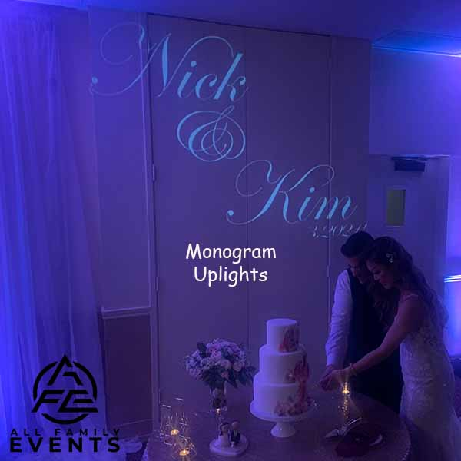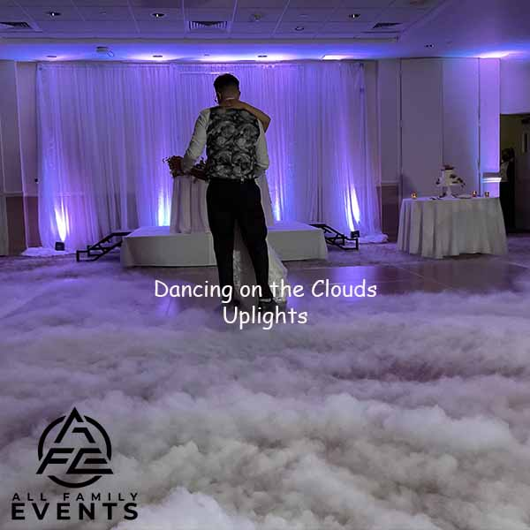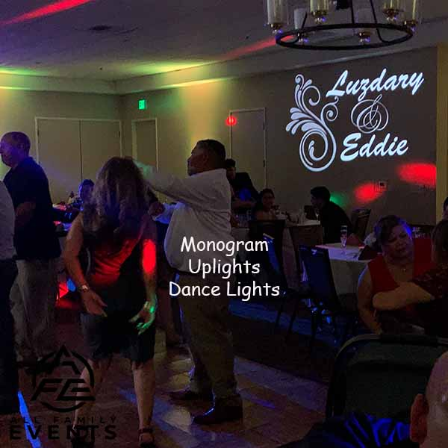

Ceremony Sound System (Included with your Package)

This system includes DJ Controller, 1 Powered Speaker on a Tripod, and 1 wireless handheld microphone on a stand, to be shared between the Officiant and the Couple. It can be used by passing it back and forth or in an interview style. We suggest adding on a second wired handheld microphone and a stand for use by a singer, and/or reader.

À la carte:

Powered Speaker with Stand $145.00 each

Yamaha 12-Input 4-Bus Mixer with Effects $175.00 each

Sennheiser Pro Vocal Wireless Microphone $175.00 each

Sennheiser Pro Lavalier Microphone $175.00 each

Shure SM58 Handheld Vocal Microphone $ 75.00 each

Tripod Boom Microphone Stand - $ 25.00 each

Electric Instrument Cable $ 20.00 each

Slideshow audio patch cable $ 25.00 each

If you decide that you want any of the Enhancements:
1) You can “e-sign” or sign contract, then pay the 50% deposit (or in full) via check or Venmo. We will send a receipt acknowledging deposit paid and contract received.
2) The balance is due 2 weeks before the Event.

All Family Events DJ & More
allfamilyevents.com
info@allfamilyevents.com
PO BOX 1467 | Martinez, CA 94553
Call/Text: (925) 812-2335
