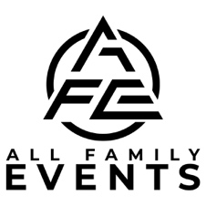

Bar/Bat Mitzvah DJ/MC MUSIC SERVICES WORKSHEET
Our objective is to provide you with the best event and music. To aid us in customizing your event and music, please fill out the following questionnaire and return by E-mail no later than 4 weeks prior to your event. Your DJ will contact you prior to your wedding to answer any questions you may have and to discuss your event in detail with you. Please edit this document, rather than printing and writing in your choices.

Bar/Bat Mitzvah's Name
Parent's Name:
Phone Numbers:
Type of Function: | Bar Bat Mitzvah's |  |  | # Of Guests:
Day: | Date: | Start Time: |  |  | End Time:
DJ Attire: Black Hawaiian Referee Baseball Basketball Hockey Other

Total number of guests attending Including children: ____________
Total number of children (ages 5-14) This is very important and can affect the games
Boys | Girls

COCKTAIL INFORMATION
Cocktail Time: _______

**PLEASE NOTE: If we will be providing the music for the cocktail and it will be in a different location than the party, there may be an additional charge for the additional system.

INTRODUCTIONS
Will there be introductions YES NO
Parent's Music: | (Artist - Title)
Siblings Music: | (Artist - Title)
Guest of Honor Music: | (Artist - Title)

Parents Frist Names: YES NO
Siblings Frist Names: YES NO
Guest of Honor:

BLESSINGS – TRADITIONS

Will a Havdalah service be done? YES NO
Given by:

Will a Hamotzi be done? YES NO
Given by:

Will a Kiddush be done? YES NO
Given by:

Would you like to do the Hora and when?
After introductions After candle lighting After meal Not doing

Who will be lifted in the chair?
Guest of Honor Mother Father Siblings Not doing

Will a parent welcome speech be done YES NO If yes, given by Typically done after candle lighting.
Given by:

CANDLE LIGHTING CEREMONY
Generally, the candle lighting order is as follows: Memory candle or candles, grandparents, aunts & uncles, cousins, family friends, neighbors, mitzvah's friends (school, camp, temple friends, etc.), siblings, parents and then the mitzvah.
**PLEASE NOTE: Please bring an additional candle with candle guard so that the other candles can be lit safely by the Guest of Honor.

Who will read the ceremony: Child Not doing?
Candle 1 (Memory) | Person(s) | (Artist - Title)
Candle 2 | Person(s) | (Artist - Title)
Candle 3 | Person(s) | (Artist - Title)
Candle 4 | Person(s) | (Artist - Title)
Candle 5 | Person(s) | (Artist - Title)
Candle 6 | Person(s) | (Artist - Title)
Candle 7 | Person(s) | (Artist - Title)
Candle 8 | Person(s) | (Artist - Title)
Candle 9 | Person(s) | (Artist - Title)
Candle 10 | Person(s) | (Artist - Title)
Candle 11 | Person(s) | (Artist - Title)
Candle 12 (Sibling) | Person(s) | (Artist - Title)
Candle 13 (Parents) | Person(s) | (Artist - Title)
Candle 14 (Guest of Honor) | Person(s) | (Artist - Title)
Special Instructions: _________________________________________________________________________________________________________
After candle lighting, would you like to sing Happy Birthday YES NO
DINNER
Meal type: Sit down Buffet Stations
Number of courses: One Two Three Four

ACTIVITIES & GAMES

Please select up to 8 activities that you would like to do
Balloon Stuff (Group 6 Max)
Balloon Tower (Group 12 Max)
Basketball Toss (1 Winner)
Coke & Pepsi (2 Winners)
Cup Tower (Group 12 Max)
Hoppy Ball Race (Group 12 Max)
Hula Hoop Challenge (1 Winner)
Limbo (1 Winner)
Mummy Wrap (Group 4 Max)
Name That TV Show (2 Winners)
Name That Movie (2 Winners)
Scavenger Hunt (1 Winner)
Other please specify

Please select any line dances that you would like to do
Beat It
Cha Cha Slide
Chicken Dance
Cotton Eyed Joe
Cupid Shuffle
Electric Slide
Gangnam Style
Hokey Pokey
Macarena
Soulja Boy
Teach me how to Dougie
Thriller
We Like to Party
Wobble
YMCA

SPECIAL DANCES - REQUESTS

Special dance for Child & Parent YES NO | (Artist - Title)
Special dance for Host & Hostess YES NO | (Artist - Title)
Last song | (Artist - Title)

Special instructions:

For continuous improvement, please share any feedback on this form with us. Thank you!

**PLEASE NOTE: FOR OUR PLANNING PURPOSES, THIS FORM WILL BE LOCKED 2 WEEKS PRIOR TO YOUR EVENT DATE. Any changes that need to be added after your account has been locked will need to be communicated to our office directly.
Dance Music Information
Below is a list of music categories. Your DJ will consult with you to determine your wishes using this information. Please fill it out as thoroughly as possible. The standard is to play a variety from all these genres during your event. For full variety, please check that selection (Full Variety). For a greater emphasis in a particular category, please indicate this by checking applicable the box(es). If you do not want one or more of the categories, please cross it off.

Full Variety Big Band Oldies 50's-60's Motown Disco Funk 80's New Wave 80's Dance 80's Hip Hop 90's Dance 90's Hip Hop
2000's Dance 2000's Hip Hop 2010's Dance 2010's Hip Hop Country Classic Rock Current Top 40 Hip Hop Bay Area
Salsa Merengue Cumbia Bachata Banda Cha Cha's

Musical REQUESTS: (Artist - Title) (If you wish to have a remix played, please be as specific as possible)
(For Conservative or Religious groups, please provide a play list of acceptable songs)
1 |  | 24
2 |  | 25
3 |  | 26
4 |  | 27
5 |  | 28
6 |  | 29
7 |  | 30
8 |  | 31
9 |  | 32
10 |  | 33
11 |  | 34
12 |  | 35
13 |  | 36
14 |  | 37
15 |  | 38
16 |  | 39
17 |  | 40
18 |  | 41
19 |  | 42
20 |  | 43
21 |  | 44
22 |  | 45
23 |  | 46
Enhancements you can add with us! Ask for pricing and availability.
Availability on some Enhancements are on first come, first served basis, so don’t miss out.
We do book these Enhancements on a separate contract.

*Uplighting: $595 per 10
Choose the perfect color for the room and for dancing
they can add excitement as they change colors.
As a show or to the beat of the music. (link)

*DJ Dance Lights Event-BAR 6: $295 ea.
Is the ultimate 6-in-1 lighting system including wash lights
and strobes for better color mixing and effects. (link)

*Dancing on the Clouds: $495
Our Cloud machine is a movie set grade machine, used in movie making. We will bring it in, sets it up, runs it for the
'specialty' dance and then takes it away. (link)

*Static Monogram: $395
Light with your name on it, we can do names or initials & more. These normally shine on the wall, or on the dance floor. (link)

*Bubble Machine: $125 or $145
One time use only $125, and all night $145. Great for end of Ceremony and/or Entrances in the room to run through, and/or as your guests to escort you out at the end of the night. It a nice replacement to sparkers, as some venues don’t allow sparkers.

Cold Sparkler Fountains: $595.00 for 2 Sparklers
Great for end of Ceremony or End of the Night. (Outside Only)

Moving Heads with Totems: $595
Fitted with a 100 W LED, Dual rotating prisms split the beam for great effects. For a true Nightclub Atmosphere.

*Snow Machine: $295
Provides the effect of snow. Meaning that the machines come with a snow fluid solution that, looks like falling snowflakes.
Have “Snow on Main Street” like at Disneyland, at your event.

*Wash Light: $125 ea.
Turn off the house lights and make the room any color
to match your envision.

Rotosphere: $95.
Picture a reverse mirror ball with LED lights shining out.

*UV Black Light: $125 ea.
Glow in the Dark Event.

*Cornhole Boards Set: $95.
4'x2' Regulation Size Wooden with LED Ring Lights.
Set up and tear down.

*Cotton Candy Machine:
Ask for pricing and availability. Everything needed with 2 Flavors: Vanilla, Blue Raspberry. Includes set up breakdown.
We wear food gloves while serving.

*Projector 5500 Lumens: $345
All the wiring needed to connect it,
just bring your laptop and we can connect it.

*Projector 5500 Lumens & Screen: $395
Projector Screen, 84-inch 16:9, Manual Floor Pull Up
Scissor Backed Portable Event Screen.

*32”or 48" Full HD LCD display:
Ask for pricing. This is perfect for Video, or
Photo Slideshow to run all night on.

*Photo Booth:
Ask for pricing and availability,
we have several and they get reserved fast!

*Karaoke Package: $325
Over 16,000 songs, 2 Karaoke Microphones
with stands, and mixing board.

*S'mores Fire Pit: $125.
We bring the fire, and you bring the supplies. (Outside Only)

*CO2 Cryo:
Ask for pricing.
For End of Ceremony, or Grand Entrance, or Dancing.

*Wireless Microphone: $175 ea.
Sennheiser Pro Audio Vocal, or Lavalier, Wireless Microphone.

*Subwoofer: $145 ea.
QSC Subwoofer KW181 1000 Watts of Deep Bass.

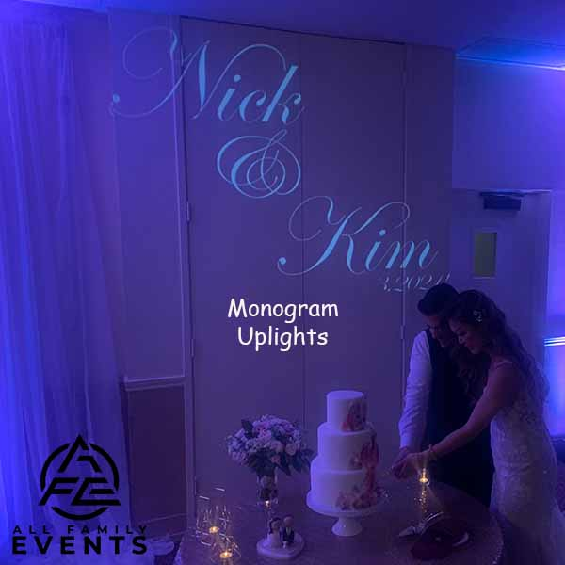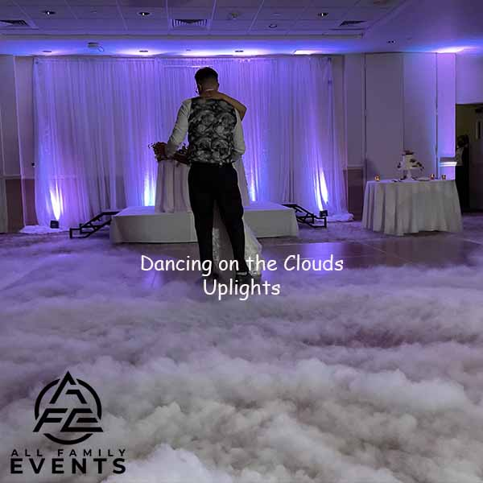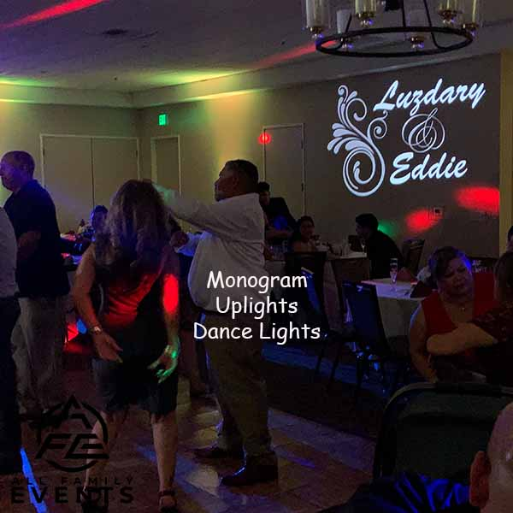

Ceremony Sound System (Included with your Package)

This system includes DJ Controller, 1 Powered Speaker on a Tripod, and 1 wireless handheld microphone on a stand, to be shared between the Officiant and the Couple. It can be used by passing it back and forth or in an interview style. We suggest adding on a second wired handheld microphone and a stand for use by a singer, and/or reader.

À la carte:

Powered Speaker with Stand $145.00 each

Yamaha 12-Input 4-Bus Mixer with Effects $175.00 each

Sennheiser Pro Vocal Wireless Microphone $175.00 each

Sennheiser Pro Lavalier Microphone $175.00 each

Shure SM58 Handheld Vocal Microphone $ 75.00 each

Tripod Boom Microphone Stand - $ 25.00 each

Electric Instrument Cable $ 20.00 each

Slideshow audio patch cable $ 25.00 each

Ceremony Sound Enhancement Package: $595.00

2x Powered Speakers with Stands

1x Yamaha 12-Input 4-Bus Mixer with Effects

2x Sennheiser Pro Audio Vocal Wireless Microphone

1x Sennheiser Pro Audio Lavalier Microphone

2x Shure SM58 Handheld Dynamic Vocal Microphone

2x XLR Male to Female Microphone Cables - 50 Feet

2x XLR Male to Female Cables - 25 Feet

3x Tripod Boom Microphone Stand - Height-Adjustable

1x Guitar Cable 18 ft Electric Instrument Cable (Right Angle)

Video / Photo Slideshow audio patch cable to sound system

Oak Tree Enhancement Package: $4495.00

All the bells and whistles in one affordable package! Everything with amazing lighting is almost as important to you as killer tunes, Dance Floor Lighting, Uplighting, Wash Light, Dancing on the Clouds, Ceremony Audio Enhancement, Monogram projected onto the floor or wall, our amazing photo booth which includes an attendant, and props!

Only one (1) Oak Tree Enhancement Package is available per night, and we do multiple events per day.

If you decide that you want any of the Enhancements:
1) You can “e-sign” or sign contract, then pay the 50% deposit (or in full) via check or Venmo. We will send a receipt acknowledging deposit paid and contract received.
2) The balance is due 2 weeks before the Event.

All Family Events DJ & More
allfamilyevents.com
info@allfamilyevents.com
PO BOX 1467 | Martinez, CA 94553
Call/Text: (925) 812-2335
