Quinceanera DJ/MC MUSIC SERVICES WORKSHEET
Please fill out the following questionnaire (Edit this document, rather than printing and writing in your choices) and return by E-mail.
Client Information
Quinceanera Date
Time
Start | End

Name of Quinceanera
Parents of Quinceanera

Other Professionals
Planner/Coordinator (If not the venue’s)?
Name | Phone | Email

Videographer?
Name | Start Time: | End Time:

Photographer?
Name | Start Time: | End Time:

Any special entertainment during the event we should know about?  YES  NO

Introductions
Introductions Music
Will there be introductions of the Parents? |  YES  NO
If Yes, Name of Parents?
Will there be introductions of the Padrino? |  YES  NO
If Yes, Name of Padrino?
Introductions of Court?  YES  NO
Damas |  | Chambelones
 | escorted by
 | escorted by
 | escorted by
 | escorted by
 | escorted by
 | escorted by
 | escorted by

Quinceanera Introduction
Quinceanera | escorted by

Shoe & Crowning Ceremony
Will there be a Shoe Ceremony | Yes or No
What song will be played?
Who will have the shoes? | Yes or No
Who will change the shoes? | Yes or No
Will there be a crowning? | Yes or No
Who will be placing the crown?

Dances
Will there be a waltz? |  YES  NO
If Yes, what song?
Artist | Title

Who will do the waltz
Will there be a dance for the court? |  YES  NO
If Yes, What Song
Artist | Title

Dance with Father? |  YES  NO
What Song?
Artist | Title

Last Doll
Will there be a presentation of Last Doll |  YES  NO
If Yes, What Song?
Artist | Title

Who will the Quinceanera present the doll to?
Name: |  | Relationship:

Welcome Speech, and More
Would the Quinceañera like to make an announcement? Speech or Thank You Yes ___ No ___
(Quinceañera should memorize or write down a speech for this event or have it on her phone)
Will you have a Slideshow or Video presentation? If so, what time would you like to play the presentation? _____________
A Video Projector and Projection Screen can be available for an Extra Cost!
Toast? What time do you want the Champagne or Sparkling Apple Cider for the Toast?
Please circle or underline: A. before meal. B. During meal. C. After meal. D. Later, during the party
Speech or Thank You Yes ___ No ___
(Quinceañera should memorize or write down a speech for this event or have it on her phone)
Will you have a Slideshow or Video presentation? And if so at, what time would you like to play the presentation? _____________
A Video Projector and Projection Screen can be available for an Extra Cost!
Cake cutting What time? ____ pm (We will cue up and play Las Mañanitas and Happy Birthday songs) More Dancing, Dancing, Dancing and Dancing.
Questions and Special announcements:
Does the Quinceañera hava a Hastag? (example, #AmyQuince2020) *if so we can announce so can tag on Twitter, IG, Snapchat etc...
Monogram? If you have us doing a Mongram, would what you like it to read?
Up Lights, if we are providing Up Lights, what color do you want, (i.e. we can match many colors, great idea to match the color of her dress also)
Enter other info if necessary.

Dance Music Information

Below is a list of music categories. Your DJ will consult with you to determine your wishes using this information. Please fill it out as thoroughly as possible. The standard is to play a variety from all these genres during your event. For full variety, please check that selection (Full Variety). For a greater emphasis in a particular category, please indicate this by checking applicable the box(es). If you do not want one or more of the categories, please cross it off.

Full Variety Big Band Oldies 50's-60's Motown Disco Funk 80's New Wave 80's Dance 80's Hip Hop 90's Dance 90's Hip Hop
2000's Dance 2000's Hip Hop 2010's Dance 2010's Hip Hop Country Classic Rock Current Top 40 Hip Hop Bay Area
Salsa Merengue Cumbia Bachata Banda Cha Cha's
Line Dancing Songs (If not check, will not be played)
Cha Cha Slide Chicken Dance Cotton Eyed Joe Cupid Shuffle Electric Slide Gangnam Style Macarena Wobble YMCA

Musical REQUESTS For Dancing: (Artist - Title) (If you wish to have a remix played, please be as specific as possible)
(For Conservative or Religious groups, please provide a play list of acceptable songs)
1 |  | 26
2 |  | 27
3 |  | 28
4 |  | 29
5 |  | 30
6 |  | 31
7 |  | 32
8 |  | 33
9 |  | 34
10 |  | 35
11 |  | 36
12 |  | 37
13 |  | 38
14 |  | 39
15 |  | 40
16 |  | 41
17 |  | 42
18 |  | 43
19 |  | 44
20 |  | 45
21 |  | 46
22 |  | 47
23 |  | 48
24 |  | 49
25 |  | 50

Enhancements you can add with us! Ask for pricing and availability.
Availability on some Enhancements are on first come, first served basis, so don’t miss out.
We do book these Enhancements on a separate contract.

*Uplighting: $595 per 10
Choose the perfect color for the room and for dancing
they can add excitement as they change colors.
As a show or to the beat of the music. (link)

*DJ Dance Lights Event-BAR 6: $295 ea.
Is the ultimate 6-in-1 lighting system including wash lights
and strobes for better color mixing and effects. (link)

*Dancing on the Clouds: $495
Our Cloud machine is a movie set grade machine, used in movie making. We will bring it in, sets it up, runs it for the
'specialty' dance and then takes it away. (link)

*Static Monogram: $395
Light with your name on it, we can do names or initials & more. These normally shine on the wall, or on the dance floor. (link)

*Bubble Machine: $125 or $145
One time use only $125, and all night $145. Great for end of Ceremony and/or Entrances in the room to run through, and/or as your guests to escort you out at the end of the night. It a nice replacement to sparkers, as some venues don’t allow sparkers.

Cold Sparkler Fountains: $595.00 for 2 Sparklers
Great for end of Ceremony or End of the Night. (Outside Only)

Moving Heads with Totems: $595
Fitted with a 100 W LED, Dual rotating prisms split the beam for great effects. For a true Nightclub Atmosphere.

*Snow Machine: $295
Provides the effect of snow. Meaning that the machines come with a snow fluid solution that, looks like falling snowflakes.
Have “Snow on Main Street” like at Disneyland, at your event.

*Wash Light: $125 ea.
Turn off the house lights and make the room any color
to match your envision.

Rotosphere: $95.
Picture a reverse mirror ball with LED lights shining out.

*UV Black Light: $125 ea.
Glow in the Dark Event.

*Cornhole Boards Set: $95.
4'x2' Regulation Size Wooden with LED Ring Lights.
Set up and tear down.

*Cotton Candy Machine:
Ask for pricing and availability. Everything needed with 2 Flavors: Vanilla, Blue Raspberry. Includes set up breakdown.
We wear food gloves while serving.

*Projector 5500 Lumens: $345
All the wiring needed to connect it,
just bring your laptop and we can connect it.

*Projector 5500 Lumens & Screen: $395
Projector Screen, 84-inch 16:9, Manual Floor Pull Up
Scissor Backed Portable Event Screen.

*32”or 48" Full HD LCD display:
Ask for pricing. This is perfect for Video, or
Photo Slideshow to run all night on.

*Photo Booth:
Ask for pricing and availability,
we have several and they get reserved fast!

*Karaoke Package: $325
Over 16,000 songs, 2 Karaoke Microphones
with stands, and mixing board.

*S'mores Fire Pit: $125.
We bring the fire, and you bring the supplies. (Outside Only)

*CO2 Cryo:
Ask for pricing.
For End of Ceremony, or Grand Entrance, or Dancing.

*Wireless Microphone: $175 ea.
Sennheiser Pro Audio Vocal, or Lavalier, Wireless Microphone.

*Subwoofer: $145 ea.
QSC Subwoofer KW181 1000 Watts of Deep Bass.

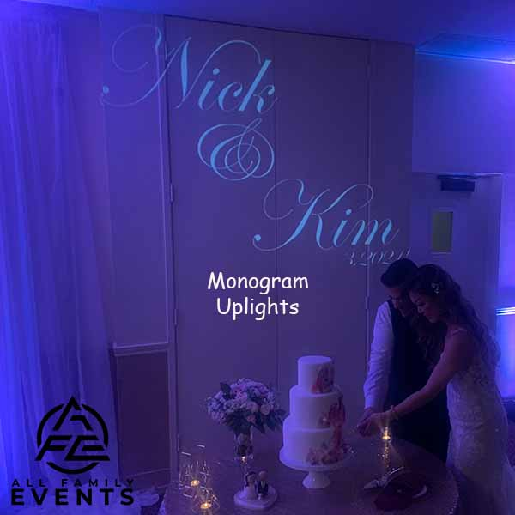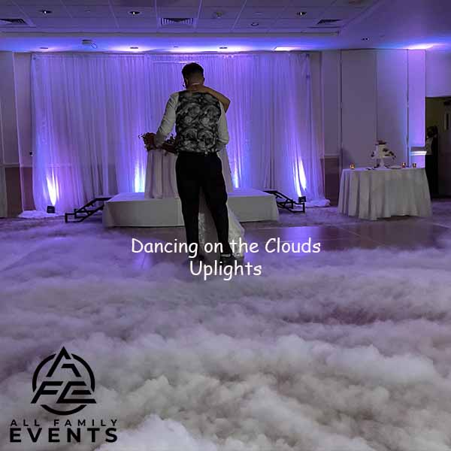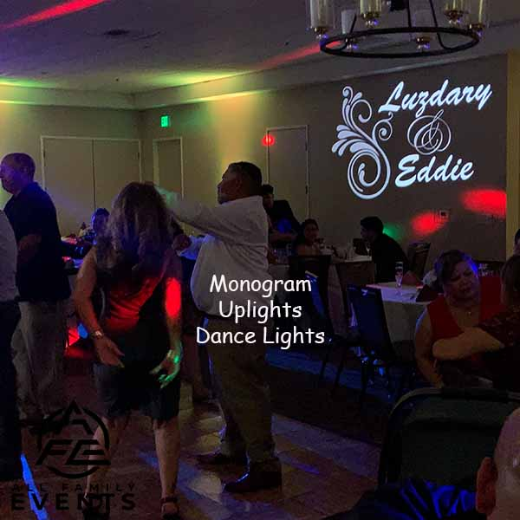

Ceremony Sound System (Included with your Package)

This system includes DJ Controller, 1 Powered Speaker on a Tripod, and 1 wireless handheld microphone on a stand, to be shared between the Officiant and the Couple. It can be used by passing it back and forth or in an interview style. We suggest adding on a second wired handheld microphone and a stand for use by a singer, and/or reader.

À la carte:

Powered Speaker with Stand $145.00 each

Yamaha 12-Input 4-Bus Mixer with Effects $175.00 each

Sennheiser Pro Vocal Wireless Microphone $175.00 each

Sennheiser Pro Lavalier Microphone $175.00 each

Shure SM58 Handheld Vocal Microphone $ 75.00 each

Tripod Boom Microphone Stand - $ 25.00 each

Electric Instrument Cable $ 20.00 each

Slideshow audio patch cable $ 25.00 each

Ceremony Sound Enhancement Package: $595.00

2x Powered Speakers with Stands

1x Yamaha 12-Input 4-Bus Mixer with Effects

2x Sennheiser Pro Audio Vocal Wireless Microphone

1x Sennheiser Pro Audio Lavalier Microphone

2x Shure SM58 Handheld Dynamic Vocal Microphone

2x XLR Male to Female Microphone Cables - 50 Feet

2x XLR Male to Female Cables - 25 Feet

3x Tripod Boom Microphone Stand - Height-Adjustable

1x Guitar Cable 18 ft Electric Instrument Cable (Right Angle)

Video / Photo Slideshow audio patch cable to sound system

Grand Oak Tree Enhancement Package: $4495.00

All the bells and whistles in one affordable package! Everything with amazing lighting is almost as important to you as killer tunes.

Dance Floor Lighting, Uplighting, Wash Light, Dancing on the Clouds, Ceremony Audio Enhancement, Subwoofer, Monogram projected onto the floor or wall, & our amazing photo booth which includes an attendant, and props!

Only one (1) Grand Oak Tree Enhancement Package is available per night, and we do multiple events per day.

If you decide that you want any of the Enhancements:
1) You can “e-sign” or sign contract, then pay the 50% deposit (or in full) via check or Venmo. We will send a receipt acknowledging deposit paid and contract received.
2) The balance is due 2 weeks before the Event.

All Family Events DJ & More
allfamilyevents.com
info@allfamilyevents.com
PO BOX 1467 | Martinez, CA 94553
Call/Text: (925) 812-2335
