DJ/MC MUSIC SERVICES WORKSHEET All Family Events DJ & More
allfamilyevents.com info@allfamilyevents.com 925-812-2335
Please fill out the questionnaire (Edit this document, rather than printing and writing in your choices) and return by E-mail.
When you see this please put a X next to show you choice.
Client Information
Contact Names:
Phone Numbers:
E-Mail Addresses:
Event Location: |  |  | Room:
Type of Function: | Ceremony & Reception Reception Only |  |  | Number Of Guests:
Day: | Date: | Start Time: |  | End Time:
Vendors
Photographer Start time: Ending: | Video Start time: Ending:
Officiate/Minister Name:  Professional, Friend, or Family: | Photo Booth: Start time: Ending:
Any special photos during the reception we should know about YES NO (i.e., group picture of all your guests, sunset picture)

Any special entertainment during the reception we should know about YES NO
(i.e., Hula Dancers, Belly Dancers, Band, Singers, Lion Dancers)
Wedding Ceremony Sheet
Ceremony Time: | Ceremony Length:
For Pre-Ceremony music please pick a genre/style rather than providing a list. Soft Contemporary Jazz RnB DJ Choice Other:
Ceremony music to be provided by. Musicians DJ (If you are using musicians, please still fill in your choices)
Ceremony Group Name /Musician(s):
Scheduled arrival time: | Will they also play during the cocktail hour YES NO
Groom / Best Man / Officiant, Mother’s Seating, and Wedding Party Processional, can be the Same or Individual song(s)
Groom / Best Man / Officiant: | (Artist - Title)
Mother’s Seating: | (Artist - Title)
Wedding Party Processional: | (Artist - Title)
Bridal Processional: | (Artist - Title)
Music During the Ceremony: Only if doing a,  Sand Ceremony, Unity Candle, Etc. | (Artist - Title)
Recessional Music: | (Artist - Title)
Special readings or soloists during the ceremony YES NO If YES, will they need additional microphones or equipment YES NO
One (1) Wireless Handheld Microphone on a Stand is included in your package.
How many readings? What are their names?
Please share any notes or details regarding your ceremony your DJ will need to know:
Cocktail Hour & Wedding Reception

Outfit Changes?  Before Dinner  After Dinner  After Toast  Time:

For Cocktail Hour and Dinner Music please pick a genre/style rather than providing a list.
Soft Contemporary Jazz Lite Classic Rock Country Motown/RnB DJ Choice Other:
Spotify Play List Link:
Wedding Party Introduction
Parents Music: | (Artist - Title)
Wedding Party Music: | (Artist - Title)
Bride and Groom Music | (Artist - Title)

Please list first names in order of introduction: (If they are related to you, please specify...i.e., Grooms Younger Brother)
Even if you are not announcing parents, please list their names: Announce parents YES NO
Groom’s Parents:
Bride’s Parents:

Announcing Flower Girls & Ring Bearers, YES NO
Flower Girl(s): | Ring Bearer(s):

Announcing Party, YES NO
Bridesmaids: | Groomsmen:
Maid / Matron of Honor: | Best Man:

Bride and Groom Announced as:
Mr. & Mrs. Smith / Mr. & Mrs. John & Jane Smith / John & Jane Smith / John & Jane / The Smiths, John & Jane
Will there be a Welcome Speech (Traditionally given by Bride’s Father or Groom) YES NO
Given by:
Will there be a Blessing Prior to Dinner YES NO
Given by:
Dinner Service
What time is Dinner is scheduled to begin ________ and the meal is  Plated  Buffet.
If you have a buffet dinner your DJ will release the tables starting with the head table and parent’s tables and working their way around to the rest of the room.
Formal Toasts
Formal Toasts can take place prior to, or after dinner. Traditionally the Best Man, Maid of Honor, and Parents” give toasts. You are welcome to schedule whomever you want. We do recommend limiting toasts to 3 to 5 minutes.
Would you like toasts to be Prior to Dinner After Dinner (Best is After Dinner)
Preferred Order:
1.
2.
3.
4.
5
6
Additional Toasters:
Do you want the DJ to invite your guests to make a toast (Open Mic) YES NO
Will you also be going to each table for YES NO Table Toasts Table Pictures Table Greetings
This is also not recommended for large groups due to the amount of time it takes to complete.
Things DJ/MC needs to remind your guests about (Please highlight reminders)
Guestbook, Cameras on the Tables, Wine Bottle to Sign, Photobook, Framed Picture of the Bride and Groom to Sign, Tree Picture (Guests Place a fingerprint on a branch and sign it), Wedding Favors, Coffee Station, Candy Bar, Gelato Cart, Chocolate Fountain, Shuttles, Money Tree, Bride & Groom’s Special Drink, Social Media #'s ____________________________________ __________________________________________________

Wedding Reception
Will there be a Video / Photo Slideshow YES NO, Person setting up the video?
Video Technician is available for an extra fee of $95.00, please consult with your DJ to make the arrangements!!
When will the video be played During Cocktails During Dinner After Dinner
Do you want any specialty games ( Shoe Game, Scavenger Hunt, songs, etc.) YES NO
If YES, who will MC the games, songs, etc. DJ Other:
Please describe what games, song, etc. you want:
Will there be any outside entertainers or musicians during the reception YES NO
If YES, Will they need additional Microphones or Equipment YES NO
Wedding Reception Special Songs
First Dance: (Artist - Title)
Do you wish to do your First Dance? Following the Introductions or After Formal Toasts
Do you wish to fade the First Dance song early YES NO If so at what point?
Is your First Dance a Choreographed Routine YES NO
Link to the song if Choreographed or Special Version (YouTube or Spotify is preferred):
Father/Daughter: YES NO | (Artist - Title)
Do you wish to combine the Father / Daughter and Mother / Son Dances YES NO
or invite Groom and Mother out 1/2 way into the Father / Daughter YES NO
Do you wish to fade the Father / Daughter song early YES NO If so at what point?
Mother / Son: YES NO | (Artist - Title)
Do you wish to fade the Mother / Son song early YES NO If so at what point?
Bridal Party Dance: YES NO | (Artist - Title)

Thank You Toast by Bride and Groom: YES NO  If you are doing Table Touches you do not need to do a Thank You |  | Both Bride Groom
Do you wish to do your Thank You Toast following the Formal Toasts or Before the Cake Cutting
Cake Cutting: YES NO | (Artist - Title)
Bouquet Toss: YES NO | (Artist - Title)
Garter Toss: YES NO | (Artist - Title)
Money Dance: YES NO (Choose 4 songs or more) DJ Money Dance Mix?  Please keep in mind the Money Dance could go longer than 4 songs. | (Artist - Title)
 | (Artist - Title)
 | (Artist - Title)
 | (Artist - Title)
Will the Bride have a purse for monetary gifts YES NO
Who will have the Pins for the Money Dance?
Pre Final Song of the Night: | (Artist - Title)
Final Song of the Night: | (Artist - Title)
Would you like your guests to escort you out at the end of the night YES NO
Will you have Sparkler or bubbles YES NO
Is there a limousine or car picking you up YES NO What Time?
Are you planning on having an After Party YES NO Announce the location YES NO
Location of the After Party:

Dance Music Information
Below is a list of music categories. Your DJ will consult with you to determine your wishes using this information. Please fill it out as thoroughly as possible. The standard is to play a variety from all these genres during your event. For full variety, please check that selection (Full Variety). For a greater emphasis in a particular category, please indicate this by checking the applicable box(es). If you do not want one of the categories, please cross it off.

Full Variety Big Band Oldies 50's-60's Motown Disco Funk 80's Dance 80's Hip Hop 90's Dance 90's Hip Hop
2000's Dance 2000's Hip Hop 2010's Dance 2010's Hip Hop Current Top 40 Hip Hop Bay Area Country Classic Rock
Salsa Merengue Cumbia Bachata Banda Cha Cha's

Spotify Play List Link for Party/Dancing:

Line Dancing Songs (If not check, will not be played)
Cha Cha Slide Chicken Dance Cotton Eyed Joe Cupid Shuffle Electric Slide Gangnam Style Macarena
Wobble Baby Shark Dance Fancy Like Boot Scootin’ Boogie YMCA The Time Warp
Watch Me (Whip/Nae Nae) Crank That (Soulja Boy) – “Superman”

More Wedding Line Dance Songs Everyone Will Know

Country Wedding Line Dance Songs
Since country music is the grandaddy of all line dances, you can bet there are more hits that make boot-tappin’-good country wedding line dance songs:
“Achy Breaky Heart,” Billy Ray Cyrus (1992)
“Honky Tonk Badonkadonk,” Trace Adkins (2005)
“Man! I Feel Like a Woman,” Shania Twain (1997)

Hip Hop Group Dance Songs
There are almost too many great hip-hop dance songs to choose from — but here are a few more, just for good measure!:
“Harlem Shake,” Baauer (2012)
“Jump On It,” The Sugarhill Gang (1999)
“Teach Me How to Dougie,” Cali Swag District (2010)

More Fun Wedding Reception Dances
Here are some of our favorite pop, Latin and R&B-inspired fun wedding reception songs:
“Thriller,” Michael Jackson (1982)
“Conga,” Miami Sound Machine & Gloria Estefan (1996)
“Twist & Shout,” The Beatles (1963)
“Sweet Caroline,” Neil Diamond (1969)

Musical DANCE REQUESTS: (Artist - Title) (If you wish to have a remix played, please be as specific as possible)
(For Conservative or Religious groups, please provide a play list of acceptable songs)
1 | (Artist - Title) | 17
2 |  | 18
3 |  | 19
4 |  | 20
5 |  | 21
6 |  | 22
7 |  | 23
8 |  | 24
9 |  | 25
10 |  | 26
11 |  | 27
12 |  | 28
13 |  | 29
14 |  | 30
15 |  | 31
16 |  | 32
DO NOT PLAY LIST: (Artist - Title or Style)

Last Question.
What year did you Graduate from High School? (Up to you if you answer) Bride: Groom:

Enhancements you can add with us! Ask for availability.
Availability on some Enhancements are on first come, first served basis, so don’t miss out.
We do book these Enhancements on a separate contract.

*Uplighting: $595 per 10
Choose the perfect color for the room and for dancing
they can add excitement as they change colors.
As a show or to the beat of the music. (link)

*DJ Dance Lights Event-BAR 6: $295 ea.
Is the ultimate 6-in-1 lighting system including wash lights
and strobes for better color mixing and effects. (link)

*Dancing on the Clouds: $495
Our Cloud machine is a movie set grade machine, used in movie making. We will bring it in, sets it up, runs it for the
'specialty' dance and then takes it away. (link)

*Static Monogram: $395
Light with your name on it, we can do names or initials & more. These normally shine on the wall, or on the dance floor. (link)

*Bubble Machine: $125 or $145
Bubbles only $125, and with Battery Pack $145.
Great for end of Ceremony and/or Entrances in the room to run through, and/or as your guests to escort you out at the end of the night. It a nice replacement to sparkers, as some venues don’t allow sparkers.

Cold Sparkler Fountains: $595.00 for 2 Sparklers
Great for end of Ceremony or End of the Night.

Moving Heads with Totems: $595.
Fitted with a 100 W LED, Dual rotating prisms split the beam for great effects. For a true Nightclub Atmosphere.

*Snow Machine: $295.
Provides the effect of snow. Meaning that the machines come with a snow fluid solution that, looks like falling snowflakes.
Have “Snow on Main Street” like at Disneyland, at your event.
*Wash Light: $125 ea.
Turn off the house lights and make the room any color
to match your envision.

Rotosphere: $95.
Picture a reverse mirror ball with LED lights shining out.

*UV Black Light: $125 ea.
Glow in the Dark Event.

*Cornhole Boards Set: $95.
4'x2' Regulation Size Wooden with LED Ring Lights.
Set up and tear down.

*2 hours of Live Spinning Cotton Candy: $495.
With 2 Flavors: Vanilla, Blue Raspberry. Includes set up breakdown. We wear food gloves while serving.
Ask about extra time.

*Projector 5500 Lumens: $395.
All the wiring needed to connect it,
just bring your laptop and we can connect it.

*Projector 5500 Lumens & Screen: $495.
Projector Screen, 84-inch 16:9, Manual Floor Pull Up
Scissor Backed Portable Event Screen.

*32”or 48" Full HD LCD display:
Ask for pricing. This is perfect for Video, or
Photo Slideshow to run all night on.

*Photo Booth:
Ask for pricing and availability,
we have several and they get reserved fast!

*Karaoke Package: $325
Over 16,000 songs, 2 Karaoke Microphones
with stands, and mixing board.

*2 hours of S'mores Fun: $445.
Fully stocked s'mores table with roasting sticks, graham crackers, chocolate, and marshmallows!
Ask about extra time.

*Co2 Cannon with one 20 lb Tank: $345.
For End of Ceremony, or Grand Entrance, or Dancing.

*Wireless Microphone: $175 ea.
Sennheiser Pro Audio Vocal, or Lavalier, Wireless Microphone.

*Subwoofer: $145 ea.
QSC Subwoofer KW181 1000 Watts of Deep Bass.

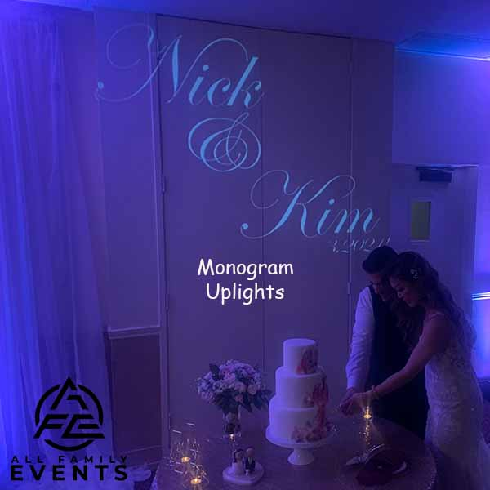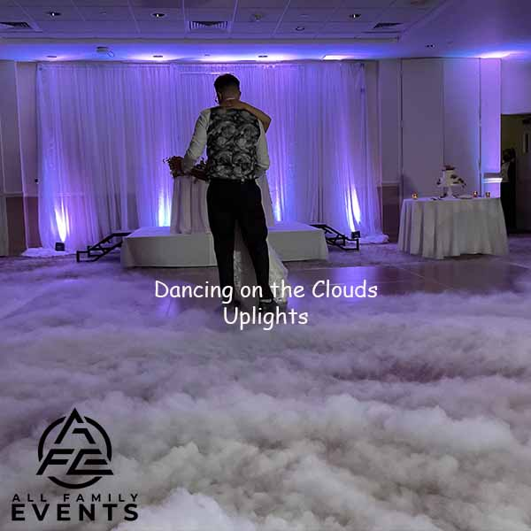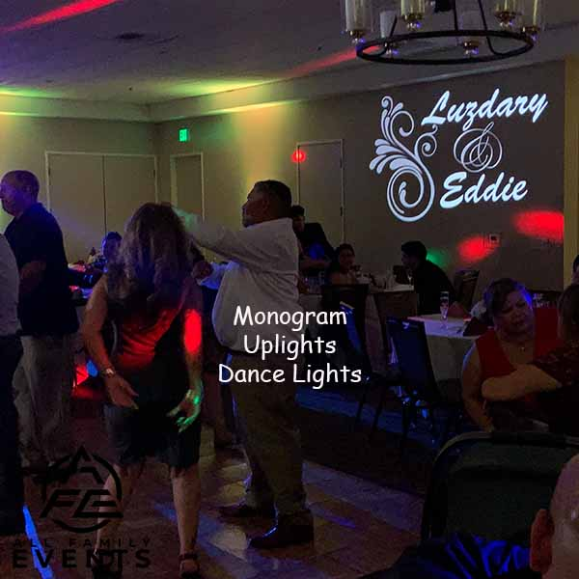

Ceremony Sound System (Included with your Package)

This system includes DJ Controller, 1 Powered Speaker on a Tripod, and 1 wireless handheld microphone on a stand, to be shared between the Officiant and the Couple. It can be used by passing it back and forth or in an interview style. We suggest adding on a second wired handheld microphone and a stand for use by a singer, and/or reader.

À la carte:

Powered Speaker with Stand $145.00 each

Yamaha 12-Input 4-Bus Mixer with Effects $175.00 each

Sennheiser Pro Vocal Wireless Microphone $175.00 each

Sennheiser Pro Lavalier Microphone $175.00 each

Shure SM58 Handheld Vocal Microphone $ 75.00 each

Tripod Boom Microphone Stand - $ 25.00 each

Electric Instrument Cable $ 20.00 each

Slideshow audio patch cable $ 25.00 each

Ceremony Sound Enhancement Package: $595.00

2x Powered Speakers with Stands

1x Yamaha 12-Input 4-Bus Mixer with Effects

2x Sennheiser Pro Audio Vocal Wireless Microphone

1x Sennheiser Pro Audio Lavalier Microphone

2x Shure SM58 Handheld Dynamic Vocal Microphone

2x XLR Male to Female Microphone Cables - 50 Feet

2x XLR Male to Female Cables - 25 Feet

3x Tripod Boom Microphone Stand - Height-Adjustable

1x Guitar Cable 18 ft Electric Instrument Cable (Right Angle)

Video / Photo Slideshow audio patch cable to sound system

Grand Oak Tree Enhancement Package: $3495.00

All the bells and whistles in one affordable package! Everything with amazing lighting is almost as important to you as killer tunes.

Dance Floor Lighting, Uplighting, Wash Light, Dancing on the Clouds, Ceremony Audio Enhancement, Subwoofer, Monogram projected onto the floor or wall, & our amazing photo booth with props!

Only one (1) Grand Oak Tree Enhancement Package is available per night, and we do multiple events per day.

If you decide that you want any of the Enhancements:
1) You can “e-sign” or sign contract, then pay the 50% deposit (or in full) via check or Venmo. We will send a receipt acknowledging deposit paid and contract received.
2) The balance is due 2 weeks before the Event.

All Family Events DJ & More
allfamilyevents.com
info@allfamilyevents.com
PO BOX 1467 | Martinez, CA 94553
Call/Text: (925) 812-2335
